**Quality Assurance (QA) Report**

**Project Name:** DATABASE FORM, DUHS  
**Date:** 19th March, 2025  
**Prepared By:** Babar Khan  
**Version:** 1.0

**1. Analysis & Findings**

**1.1 Employee ID Validation Issue**

* **Issue:** Upon entering an incorrect **Employee ID (EMPLID)**, the system displays an incorrect error message:  
  **"Sorry NIC Number Not Exists 33333-3333333-3"**
* **Recommendation:** Update the validation logic to ensure the correct error message is displayed based on the actual input field (EMPLID).

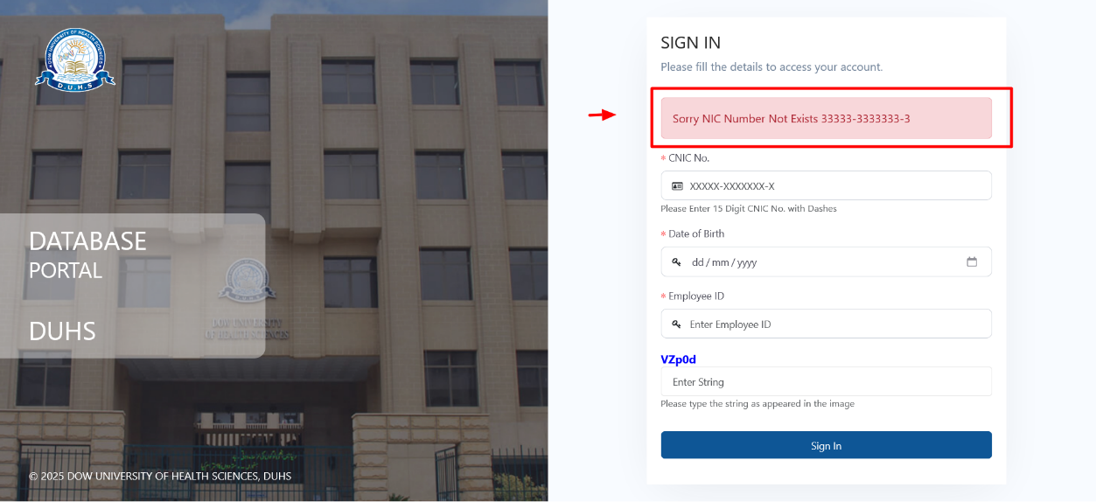

**1.2 Email Validation Issue**

* **Issue:** The system accepts invalid email formats and updates records without validation.
* **Recommendation:** Implement strict email validation to ensure only properly formatted email addresses (e.g., [user@example.com](mailto:user@example.com)) are accepted.

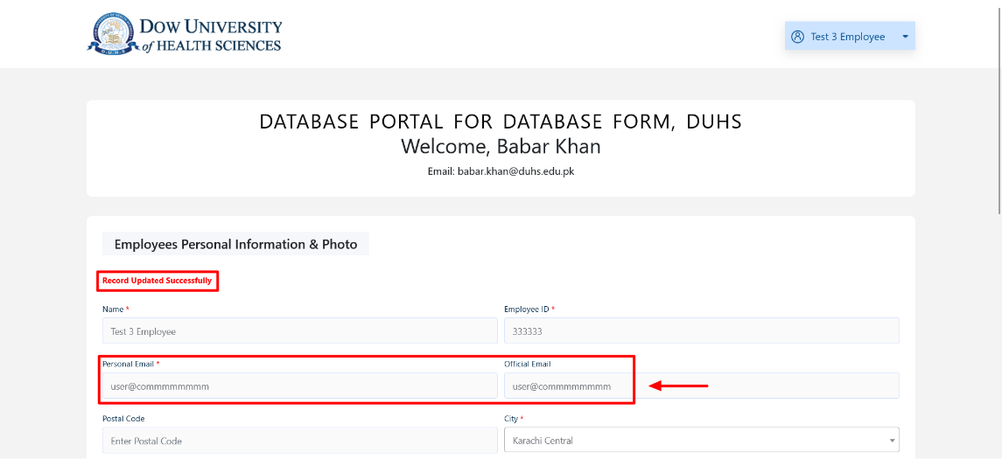

**1.3 Page Refresh Causes Duplicate Submissions**

* **Issue:** Upon refreshing the page, the message **"Record Updated Successfully"** is not removed, leading to repeated data submissions.
* **Recommendation:** Implement a mechanism to prevent duplicate form submissions upon page refresh. A success message should be cleared or removed automatically after a short delay.

**1.4 Mandatory Field Validation: City**

* **Issue:** The **City** field is missing, but the form submits successfully despite City being a mandatory requirement.
* **Recommendation:** Ensure validation for the city field is enforced before allowing form submission.

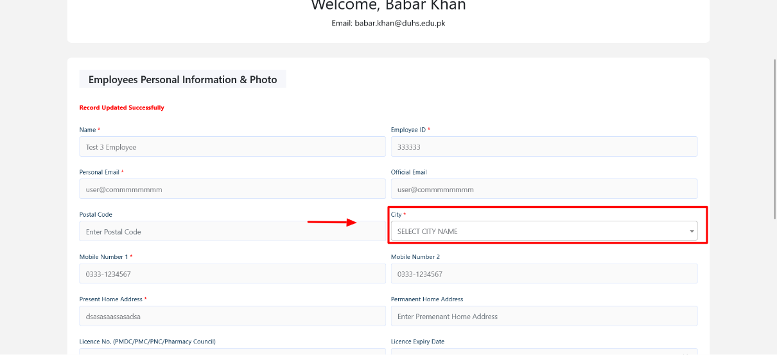

**1.5 Postal Code Validation Issue**

* **Issue:** The Postal Code field accepts special characters.
* **Recommendation:** Implement a validation rule to allow only numeric values for Postal Code (e.g., 12345).

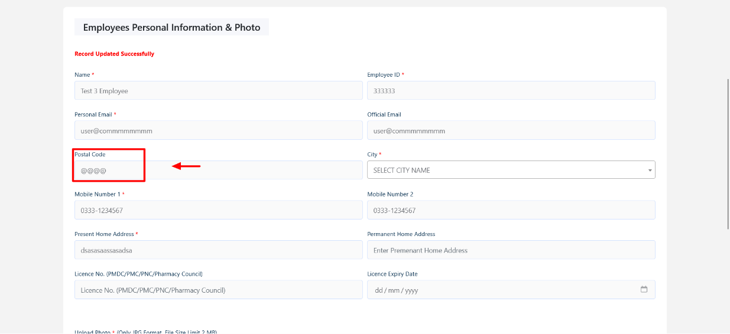

**1.6 License Number Validation Issue**

* **Issue:** The License Number field allows special characters (e.g., "@@@@----$$##").
* **Recommendation:** Restrict the format to follow **"PMDC-12345"** structure (PMDC prefix + digits).

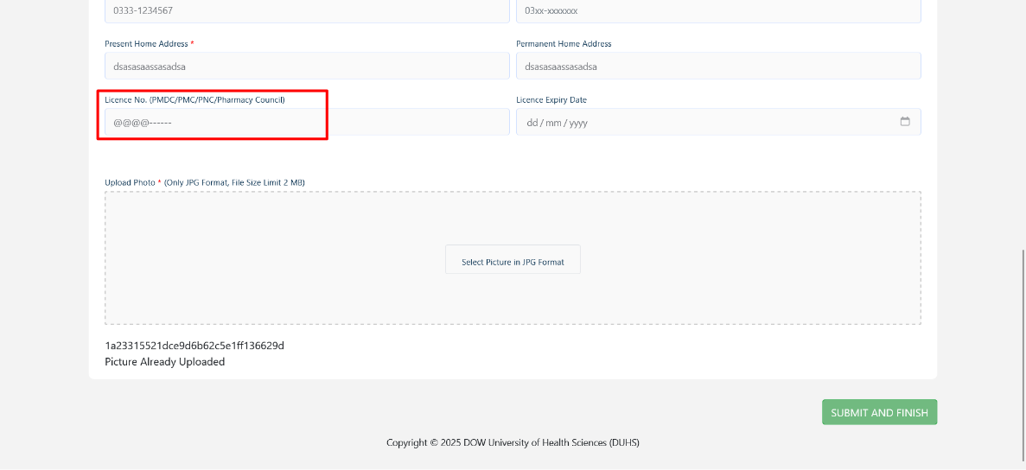

**1.7 Picture Upload Issue**

* **Issue 1:** When a new picture is uploaded, the updated image appears, but an incorrect message is displayed:  
  **"Picture Already Uploaded"**

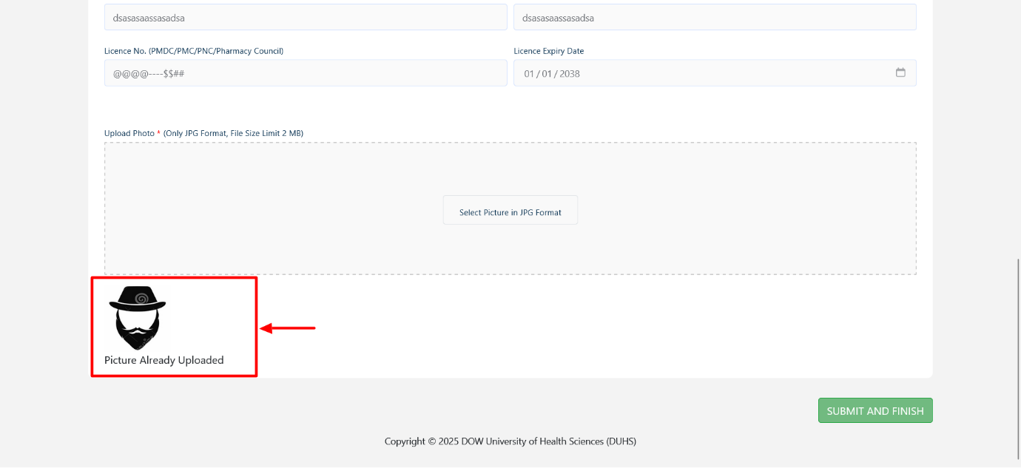

* **Issue 2:** When submitting the form without uploading a picture, an error appears, even though a picture is mandatory.

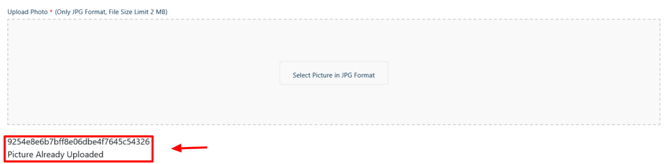

* **Recommendation:** Ensure appropriate validation messages are displayed based on the upload status. The system should differentiate between an **already uploaded** image and a **new upload requirement**.

**1.8 Spelling Correction**

* **Issue:** The spelling of **Licence** should be corrected to **LICENSE**.
* **Recommendation:** Update the spelling in all relevant sections to maintain consistency.

**2. Recommendations Summary**

|  |  |  |
| --- | --- | --- |
| Issue | Current Behaviour | Recommended Fix |
| Employee ID Validation | Incorrect error message displayed | Update validation logic for correct field-based error messages |
| Email Validation | Accepts invalid email formats | Implement strict email format validation |
| Page Refresh & Duplicate Submission | Success message persists, causing duplicate submissions | Clear success message & prevent duplicate submissions |
| Mandatory Field (City) | Form submits without City input | Enforce mandatory validation for City field |
| Postal Code Validation | Accepts special characters | Restrict input to numeric values only |
| License Number Validation | Accepts special characters | Restrict format to **"PMDC-12345"** structure |
| Picture Upload Issue | Incorrect error messages for uploads | Ensure correct validation messages for uploads |
| Spelling Correction | "Licence" spelling error | Correct to "LICENSE" |

**3. Conclusion**

The issues identified in this QA report should be addressed to improve form validation, user experience, and data integrity. Implementing these fixes will enhance the usability and accuracy of the **DATABASE FORM** system.